## Distance Converter *

Your task is to convert from **one** distance unit to **another** by adding a **click** event listener to a button. When it is clicked, **read** the value from the input field and **get** the **selected** option from the **input** and **output** units dropdowns. Then **calculate** and **display** the converted value in the **disabled** output field.

### Example

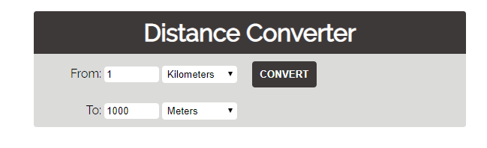

### Hints

* Multiply the incoming distance by the following conversion rates to convert to meter
* Divide to convert from meters to the required output unit
* To see which option is selected, read the properties of its parent: **value** gives you the value of the selected option (as displayed in the HTML), **selectedIndex** gives you the 0-based index of the selected option. For example, if miles are selected, **inputUnits.value** is "**mi**", **inputUnits.selectedIndex** is **4**. Option text is irrelevant
* Use the following table information to do that:

|  |  |
| --- | --- |
| **1 km** | **1000 m** |
| **1 m** | **1 m** |
| **1 cm** | **0.01 m** |
| **1 mm** | **0.001 m** |
| **1 mi** | **1609.34 m** |
| **1 yrd** | **0.9144 m** |
| **1 ft** | **0.3048 m** |
| **1 in** | **0.0254 m** |